LOCKED OUT OF WEBSITES 2018
Unofficial Guide
REQUIRED:
- Internet Explorer
- current installed Java
- some websites require specific browser settings, SEE Appendix A
- most websites have to be logged into every 30 days or you will be locked out
- CAC reader and an unlocked CAC Card (after 3 unsuccessful PIN entry attempts your card will be locked out, and you have to report to a NOSC to unlock, see Appendix B
- ***Many websites are easily accessible via http://navygirl.org/ or http://kellybeamsley.com/navy/

- NMCI (navy.mil email account): Use EMAIL CERTIFICATE. REQUIRED for ADT to MSCPAC, must log in every 60 days
- Access:
  - through the Navy Homeport https://navyreserve.navy.mil/Pages/default.aspx
  - directly at: https://webmail.east.nmci.navy.mil/ https://webmail.west.nmci.navy.mil/
- How to unlock it: Directions in Appendix C. Fill out a SAAR_N form:
https://navalforms.documentservices.dla.mil/formsDir/_OPNAV_5239_14_7631.pdf
- When you have completed SAAR_N form, scan and email to Program Office at mmr_program_office@navy.mil. In body of email include whether or not it has been more than 90 days since you last accessed your email account. Must include My Navy Portal (formerly NKO, sign in and go to bottom right: Training/Education/Qualifications, then Navy eLearning) completion certificates for:
  - Uncle Sam’s OPSEC
  - Cyber Awareness – new version for 2018 https://iatraining.disa.mil/eta/disa_cac2018/launchPage.htm
  - Anti-Terrorism
  - PII Awareness Training
If you do not have a CAC Card or My Navy Portal Access, you can get the training here:
    - https://iatraining.disa.mil/eta/piiv2/launchPage.htm
    - https://www.marinenet.usmc.mil/my.policy
    - http://jko.jten.mil/courses/atl1/launch.html
    - https://iatraining.disa.mil/eta/disa_cac2018/launchPage.htm

- NAVY RESERVE HOMEPORT: Use EMAIL CERTIFICATE. Provides useful info, access to instructions, and helpful links. Must login every 60 days.
  - Access:
    - Look for the ‘sign in’ icon on the top right of the page, this will direct you to the private navy reserve homeport: https://navyreserve.navy.mil
  - When logged in, locate ‘Commands’ on the top toolbar:
Commands -> CNRFC -> N-Codes -> N1 Manpower & Personnel (click). On the N1 page, look towards the top, find and click N14 – Strategic Sealift Officer Program.

- NSIPS (Navy Standard Integrated Personnel System), must login every 60 days
  - Access:
    - https://nsipsprod.nmci.navy.mil/nsipsclo/jsp/index.jsp
    - Make sure system is ONLINE/Green (at top of start page). If not, try again later
    - CAC login (use your IDENTITY certificate, NOT e-mail certificate)
    - ESR (Electronic Service Record) - Dependency Data (Page 2) required to be updated and verified/time stamped within 180 days of start of orders or you CANNOT BE PROCESSED FOR PAY
    - Update civilian employer information under ESR as needed

  - How to unlock it:
    - On the NSIPS main page, click on ‘NSIPS Self-Service (Unlock). On the first screen, select the employee ID box, type full social and press Tab. For rank/grade, search for your rank only, i.e. Ensign, Lieutenant Junior Grade, etc. Enter your date of birth. Enter your home of record state (HOR state may not be recognized. If so, leave blank. If successful, green text will appear on the bottom of the window stating your account is unlocked.
    - If the self-unlock did not work, contact NSIPS help desk (877) 589-5991 Nsipshelpdesk@navy.mil

  - If you need to Update your Page 2: Marriage, Divorce, Birth, Death, Adoption, change of Address, change of Dependents
    - Go online to https://nsips.nmci.navy.mil/
    - CAC login (use your IDENTITY certificate, NOT e-mail certificate)
    - For first time users click on the “ESR SELF SERVICE (NEW USER)” link
    - ESR (Electronic Service Record) Home page. At the top of home page ensure that correct SSN, Name, Rank/Rate appear
    - Click on “Personal Information”, click on “Dependency Data”
    - Make NO CHANGES on computer. Scroll to the bottom and select the radial button “Print Form”. Select “OK” for all pop ups.
    - Scroll to top of the screen, select “Main Menu” and once the menu drops down, select “NSIPS Report Manager”
    - You will have 2 documents pending, once the one called “Dependency Application” has posted, click on the “View” button. Use the refresh button on the page until the View button appears.
- Select and print middle file from “File List” (it should be xxxxx.PDF file)
- Take a pen and legibly draw line through any incorrect information, initial, and write the correct information near it. Sign and date above your name on the last page. Black out all pages where your SSN is listed.
- Scan document and any original supporting documents (birth certificate, proof of birth letter, marriage certificate, death certificate, adoption court order, etc.) You do not need any documentation to change a dependent’s address, but if they move due to a divorce, we need the divorce decree
- Preferred delivery method is via AMRDEC, the Army encryption website: https://safe.amrdec.army.mil/safe/ because of PII on these documents. You do not have to have CAC. Send to MMR_Program_Office@navy.mil , title document PAGE 2 UPDATE
- SSOP Office will make the changes in NSIPS provide a clean copy for your review. We will only respond by placing it into ARMDEC. We will not email it to you unless it is to your .mil email address and can be encrypted.
- Review the new page 2 and sign on the last page if it is correct. Then scan and return it to us via AMRDEC.
- SSOP will send you final copy with all signatures for your records.

- NROWS (Navy Reserve Orders Writing System): Use EMAIL CERTIFICATE, log in once every 60 days.
- Access:
  - https://nrows.sscno.nmci.navy.mil/nrows/secure/login.jsp
  - or on the N14 SSO Page, or through the secure reserve homeport
- How to unlock it: Note the special settings to ensure NROWS will operate correctly on your browser in Appendix A. Unlocking NROWS will require a call to the help desk at (800) 537-4617. The process could take up to 30 minutes.

- BOL (Bupers Online): Use NON-EMAIL CERTIFICATE. Login once every 90 days.
- Access:
  - https://www.bol.navy.mil
  - or via the Navy Reserve Homeport, or through the N14 SSO page
- Bupers is primary way to track your personal record. Here you will find your Retirement points (ASOSH), your PFA/PRT record (PRIMS), your Officer Service Record (OSR), and your FITREP Summary. PRIMS is critical to complete PFA, as you must fill out PARFQ questionnaire before being able to participate.
- How to unlock it: call the help desk at (800) 951-6289.

- NKO (Navy Knowledge Online): now My Navy Portal. Use EMAIL CERTIFICATE
  - Access:
    - https://wwwa.nko.navy.mil/
    - or through the Navy Reserve Homeport, or through the N14 SSO Page
    - Click on link to transfer you to My Navy Portal
- sign into My Navy Portal and go to bottom right: Training/Education/Qualifications
- Navy eLearning
- “click here to access your Navy Training Courses”
- For orders to be approved in NROWS, you will need to complete Information Awareness Training and Anti-Terrorism/Force-Protection Training Level 1 (ATFP1).
- Also found here: MSC101, TIPs, and other courses required for the SSO Warfare Pin, including Correspondence Courses for retirement points. Also courses for NMCI unlock.
- How to unlock it: Contact the NKO Help desk at (877) 253-7122

- DTS (Defense Travel System): Use EMAIL CERTIFICATE. Use this to access Travel Vouchers and upload receipts/substantiating records for when you RETURN from ADT
  - Access:
    - https://www.defensetravel.osd.mil/
  - Must submit travel voucher within 5 business days of returning to HOR after ADT
  - How to unlock it: Verify that you have the correct browser and JAVA settings noted in Appendix A and ensure your browser is in compatibility mode: http://www.defensetravel.osd.mil/firsttimeusers
  - DTS Does not require any logins after the original
  - If you have never used DTS, follow the prompts for first time users (self-registration). If the problem persists, contact the help desk at (888) 435-7146.

- MyPay: Use EMAIL CERTIFICATE. Log in once every 150 days.
- Access:
  - https://mypay.dfas.mil/mypay.aspx/.
  - link can also be found on the N14 page and the Navy reserve homeport
- MyPay is where you will ensure your EFT (Electronic Funds Transfer) information is correct, without it, you will not get paid.
- You can access LES (Leave Earning Statement) from MyPay, which will be needed to claim your uniform reimbursement
- How to unlock it: contact MyPay help desk at (888) 332-7411.
APPENDIX A: Internet Explorer Settings
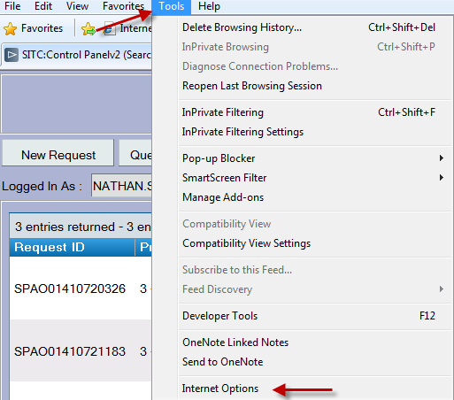
BROWSER SETTINGS FOR ACCESSING NROWS/DTS IN INTERNET EXPLORER 11
1. With the browser open navigate to Tools > Internet Options
Alt + T > Internet Options

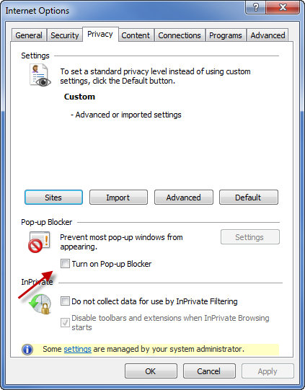
2. Click on the Privacy Tab and ensure pop-up blocker is turned off. Turn on Pop-up Blocker should be unchecked.

3. Click on the Advanced Button
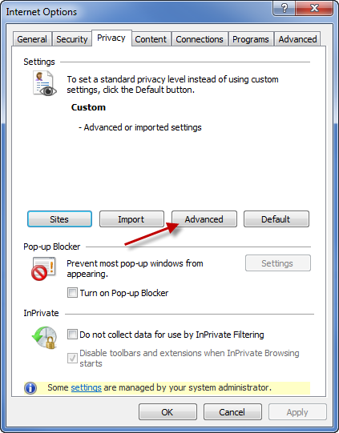

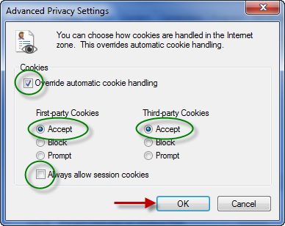
4. Verify the following settings:
Override automatic cookie handling – Unchecked

First-party Cookies and Third-party Cookies on Accept

Always allow session cookies – Unchecked

Click OK

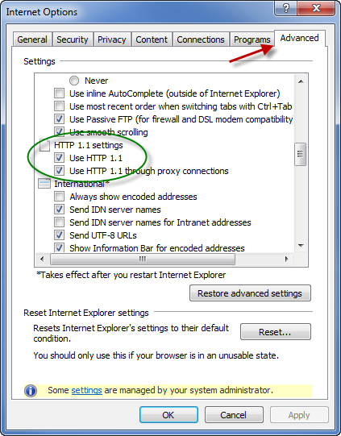
5. Click on the Advanced tab and verify the following settings
HTTP 1.1 Settings
HTTP 1.1 and HTTP 1.1 through proxy connections – Checked
If there is a third checkbox option under this setting ensure it is Unchecked

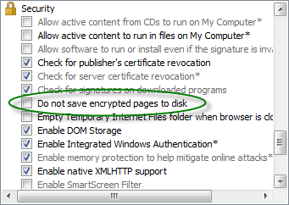
6. Security
Do not save encrypted pages to disk – Unchecked

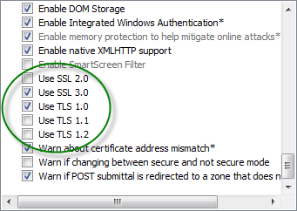
7. Use SSL 2.0 – Unchecked
Use SSL 3.0 – Checked
Use TLS 1.0 – Checked
Use TSL 1.1 – Unchecked
Use TLS 1.2 - Unchecked

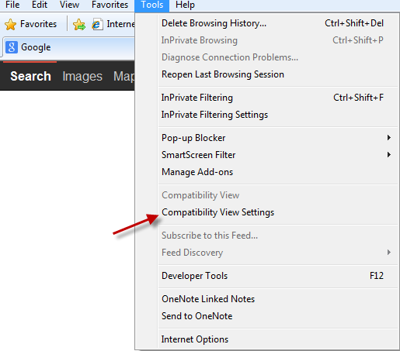
8. With the browser open navigate to Tools > Compatibility View Settings
Alt + T > Compatibility View Settings

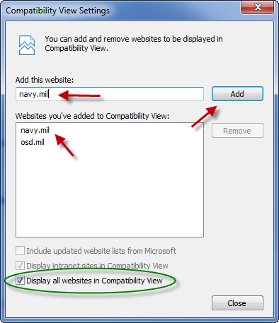
9. In the “Add this website” box type navy.mil and osd.mil and click Add. Put a check in the Display all websites in Compatibility View.

- Click close and refresh the browser and attempt to log into NROWS/DTS. IF THIS DOES NOT WORK, to return all settings to default settings:

navigate to Tools > Internet Options

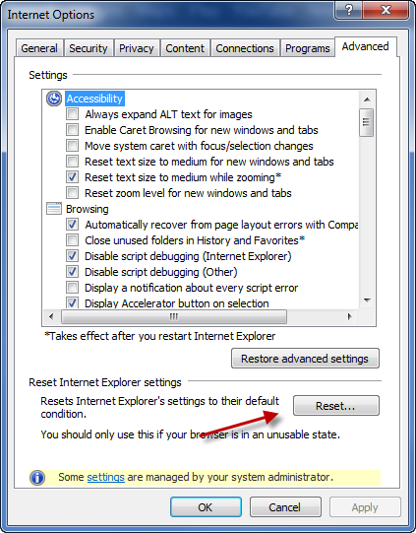
- Select Advanced Tab and clock the Reset button under “Reset Internet Explorer settings”

Defense Travel System Specific Problem with DBSign:

I. GENERAL SOFTWARE UPDATE INFORMATION

Issue: Internet Explorer 11 recently incorporated software changes that are preventing browser and JAVA detection from operating correctly during the DTS login. As a result, DTS users are unable to log in to DTS. Users receive the “DBsign Installation Page,” directing them to install JAVA when it is already installed. Reinstalling JAVA does not resolve the issue.

Workaround:
- First, verify that you are using Internet Explorer 11 by following the below steps:
  - In Internet Explorer, select the gear-shaped Tools button in the upper right corner, then select “About Internet Explorer”.
  - In the About Internet Explorer window, Internet Explorer 11 will appear: Internet Explorer 11 Issue

- If you are using Internet Explorer 11, please follow these steps. This workaround will only resolve this issue specifically with Internet Explorer 11.
  - In Internet Explorer 11, select the gear-shaped Tools button in the upper right corner, then select “Compatibility View Settings”.
  - In the Compatibility View Settings window, ensure that “osd.mil” is included in the “Add this website” field and select the Add button. You can then close the settings window.
  - Internet Explorer should refresh the page and the DTS Privacy and Ethics page should appear (it may be necessary to close IE11 and revisit DTS first).

Source (with screenshots): http://www.defensetravel.dod.mil/Docs/Internet_Explorer_11_Issue.pdf
APPENDIX B: Unlocking your CAC Card
Under most circumstances, your CAC has been locked due to 3 cumulative incorrect PIN entries. It is advisable to make your PIN something easy to remember so as not to forget it in between uses.
- To understand your specific issue, visit https://militarycac.com/CAC.htm.
2. When you have determined that your CAC is blocked or has another issue, visit https://www.dmdc.osd.mil/rsl to find a location nearby where you can go to have your PIN reset. It may be beneficial to set up an appointment.
*Note: In order to reset your PIN, you will need to personally be present and have at least one additional form of picture Identification
*Note: CAC cards may be renewed/replaced at the same sites if your CAC expires within 30 days or if it is physically damaged. More information on replacements/renewals and lost or stolen ID cards can be found at: http://www.cac.mil/common-access-card/managing-your-cac/
*For a lost or stolen CAC card, you will need to file a report with a Military Base Police Station and obtain an authorization from the Program Office to obtain a new CAC. When reporting to a RAPIDS site, you will need a copy of the Police Report, the Program Office’s authorization, as well as two forms of ID to obtain a new CAC card.

Appendix C: Completing a SAAR_N Form
SAAR_N Form : https://navalforms.documentservices.dla.mil/formsDir/_OPNAV_5239_14_7631.pdf
If filled out online, the form must be completed and printed it cannot be saved. You can also print the form and legibly fill out the fields. To fill out the form:
Type of request: Modification
Date: Today’s Date
System Name: NMCI
Location: Norfolk, VA
Block 1: Your Name
Block 2: COMNAVRESFORCOM
Block 3: N14, Strategic Sealift Officer Program, 2525M
Block 4: Leave DSN Blank, Your Phone # in COM
Block 5: Your Official Navy.Mil address
Block 6: Your Rank
Block 7: Your Address
Block 8: Your Citizenship
Block 9: Military
Block 10: You must have completed IA Training within one year.
Block 11: Your DOD ID Number (Located on the back of your CAC Card)
Block 12-22: SKIP THESE
Block 23, 24, 25: Read, Sign and Date
Block 26-33: SKIP THESE

Appendix D: Less Frequented Websites
MilConnect –
https://www.dmdc.osd.mil/identitymanagement/authenticate.do?execution=e3s1
NFAAS (Navy Family Accountability and Assessment System)
https://nfda.navyfamily.navy.mil
TWMS (Total Workforce Management Services)
https://twms.navy.mil/login.asp
Navy Reserve Readiness Module (NRRM)

https://nrrm.navyreserve.navy.mil/nrrm.Web/Modules/DoDWarning/Warning.aspx

DEERS Verification/Self Service

https://www.dmdc.osd.mil/appj/dwp/index.jsp

Navy Education and Training Command (NETC)

https://www.netc.navy.mil/

TRiPS (Travel Risk Planning System)

https://trips.safety.army.mil/navy/login.aspx?ReturnUrl=%2fnavy%2fdefault.aspx

Tricare

http://www.tricare.mil/

